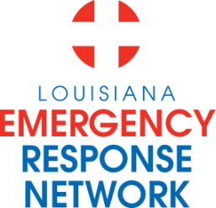

Louisiana Emergency Response Network
Board Meeting
April 16, 2015
1:00pm – 3:00pm
Location: Louisiana Emergency Response Network - Headquarters
14141 Airline Hwy, Suite One, Suite B Baton Rouge, LA 70817

AGENDA
1. Welcome LERN Board Members
2. Roll Call and Establish a Quorum
3. Approval of Agenda
4. Approval of Minutes of 1/20 Board Meeting
5. LERN Business:

- Ratification of Commission Members J. Hunt, MD

b. Executive Director Report/Annual Report P. Hargrove
- Proposed Legislation

- Level IV Trauma Centers P. Hargrove

d. Stroke System Update Sheryl Martin-Schild, MD
- Update
- Acute Stroke Ready Hospitals

e. STEMI System Update Murtaza Ali, MD
- Update/Systems Report

f. Trauma System Update R. Coscia, MD
- Region 8 Study Resolution C. Slaughter/Sen. White

g. Regional Commission Update (2, 4, & 5) Ted Colligan

h. Budget/Finance P. Sullivan/C. Woods
- Contract Renewals

i. Dr. Hunt /Closing Remarks J. Hunt, MD

6. Public Comment
7. Adjournment
Next Board Meeting – August 20, 2015

